Atitit 条件逻辑表达式的ast结构 java c# sql

**public** **static** **void** **main**(String[] args) {

String **a** = **null**;

String **b** = **null**;

String **c** = **null**;

**if**( a.equals("v1")&& ( b.equals("v2") || c.equals("v3")))

System.***out***.println("ok");

// return this;

}

If表达式

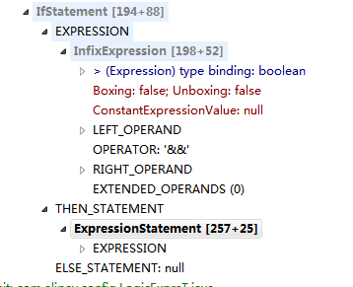

## 逻辑表达式

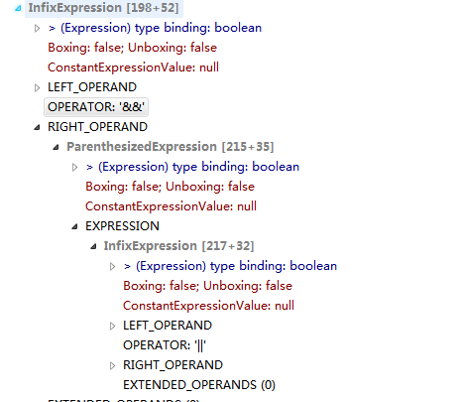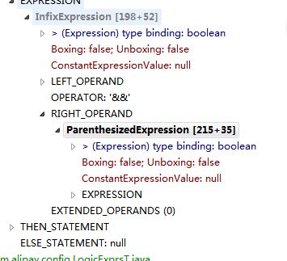

**public** **class** InfixExpression **extends** Expression

{

/* 246*/ Expression leftOperand = **null**;

String operator;

/* 252*/ Expression rightOperand = **null**;

}

**package** com.attilax.ast;

//import org.eclipse.jdt.core.dom.Expression;

// kwahao exp

**public** **class** ParenthesizedExpression **extends** Expression

{

**public** Expression expression;

}